1.

|  |
| --- |
| Class:  Tablet |
| Properties:  Brand: string  Model: string  GPU: string |
| Behavior:  call() : void  playGame() : void  notification() : void |

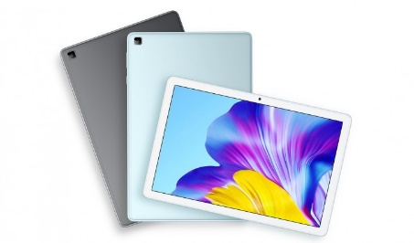

|  |
| --- |
| Class:  Multicooker |
| Properties:  Brand: string  Model: string  BowlCapacity: string |
| Behavior:  simmer() : void  boil() : void  steam() : void |

2.

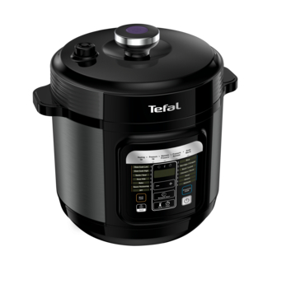

|  |
| --- |
| Class:  Smart Watch |
| Properties:  Brand: string  Model: string  ReleasedYear: int |
| Behavior:  notification() : void  call() : void  displayTime() : void |

3.

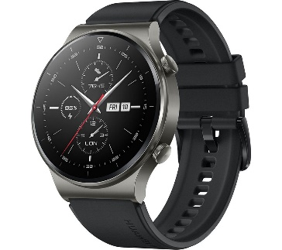

|  |
| --- |
| Class:  Breakfast Maker |
| Properties:  Brand: string  Voltage: string  OvenCapacity: string |
| Behavior:  bake() : void  toast() : void  fryEgg() : void |

4.

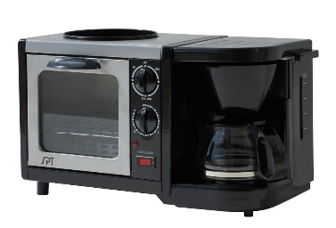

5.

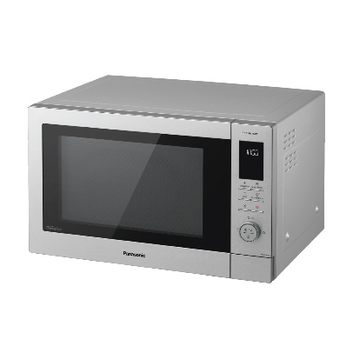

|  |
| --- |
| Class:  Microwave Oven |
| Properties:  Brand: string  Model: string  OvenCapacity: string |
| Behavior:  bake() : void  grill() : void  defrost() : void |